**COMPUTER NETWORK PRACTICALS USING WIRESHARK:**

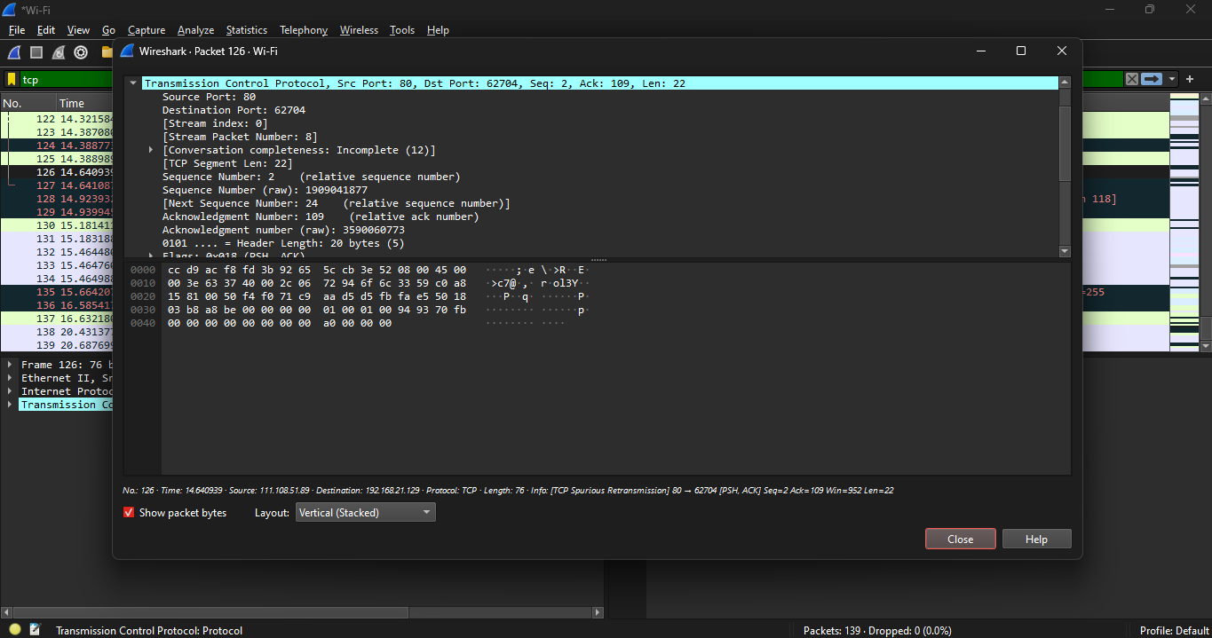

**EXPERIMENT 23: TRANSPORT LAYER PROTOCOL TCP AND UDP**

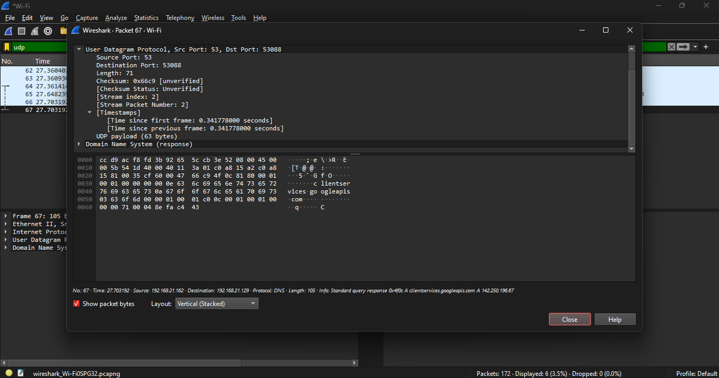

**EXPERIMENT 25: NETWORK LAYER PROTOCOL ARP AND HTTP**

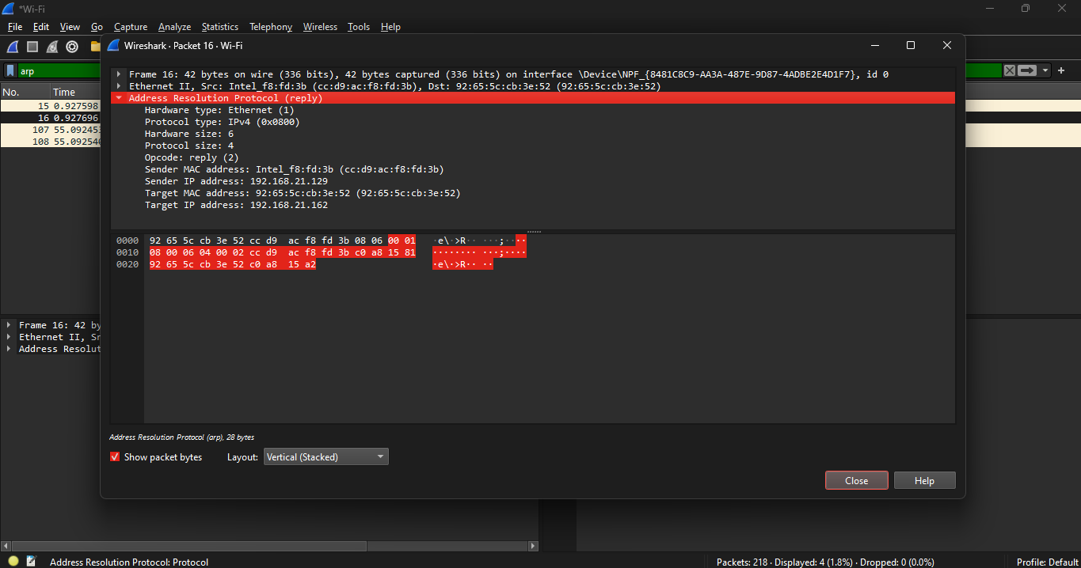

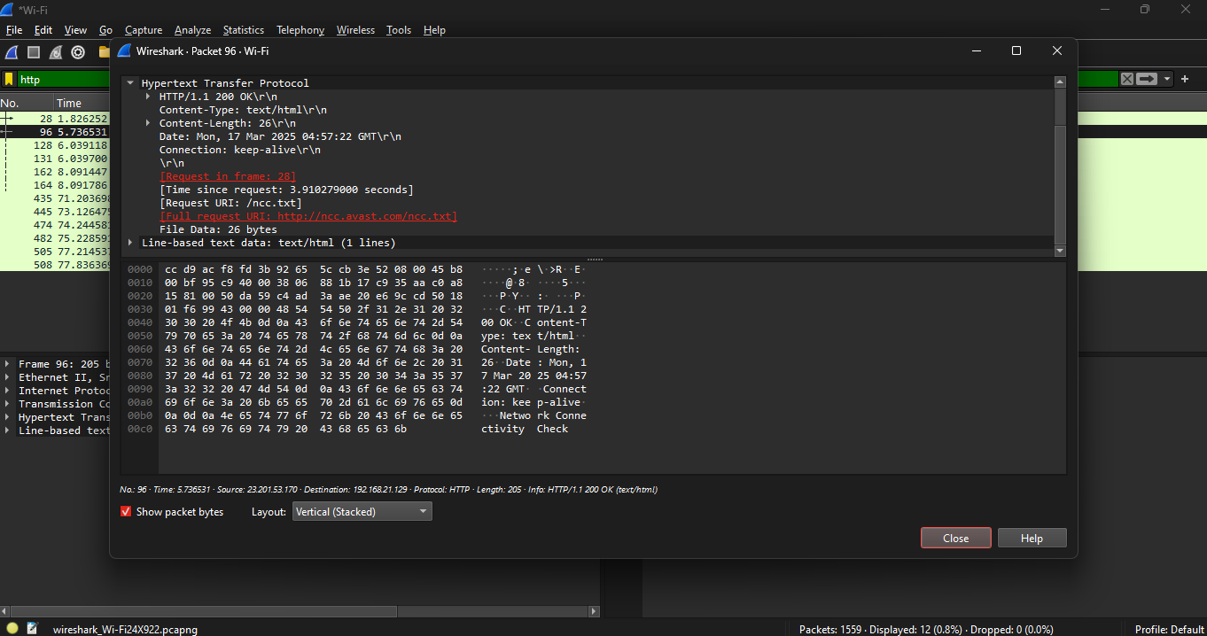

**EXPERIMENT 24: NETWORK LAYER PROTOCOL SMTP AND ICMP**

